(Approx. 725 words)

Web Surfing for Music
By Len Nasman, Webmaster, Bristol Village Computer Club, OH
September/October issue, BVCC Newsletter
http://bvres.org/bvcchome.html
Webmaster (at) bvres.org

I had a little time to kill the other day, so I went web surfing. One category of things I investigated was strange musical instruments.

Auto Playing Music Machines

During my surfing, I found some YouTube videos of music boxes in a museum in Holland that Diana and I visited during our Tulip Time Trip.

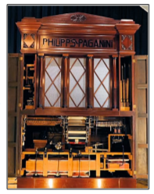
The Museum Speelklok has a large collection of music boxes and auto playing musical instruments. One of these was the Paganini. A fellow from Wintergatan (which is yet another story) was provided with a special demonstration of this amazing machine. Clicking on the photo links to a video tour of the Paganini.

The Paganini uses paper rolls to cause multiple musical instruments to play. This is like a player piano on steroids. The Paganini was built to be inside a building, however, some similar machines were for outdoor use. For example, the picture is of a giant fairground organ.
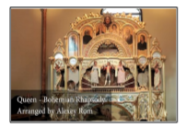
If you watch the Paganini video, you will see the operator loading the program into the machine. This machine uses large linked punched cards that look like a giant version of player piano rolls that are flat cards linked together. This technology was borrowed by earlier automated weaving machines.

The Jacquard machine was a device fitted to a power loom that simplifies the process of manufacturing textiles with such complex patterns as brocade, damask and matelassé. It was invented by Joseph Marie Jacquard in 1804. The loom was controlled by a "chain of cards", a number of punched cards, laced together into a continuous sequence.

Strange Musical Instruments

If you want to be amused, try Googling strange musical instruments. There is a whole world of creative folks who invent or play very unusual instruments. Some are fairly well known… such as Benjamin Franklin’s harmonium.

It seems that Franklin likes the sound of rubbed wine glasses, but got tired of having to set up a table full of glasses, add the right amount of water to tune each glass and then play… kind of like Robert Tiso in this example.

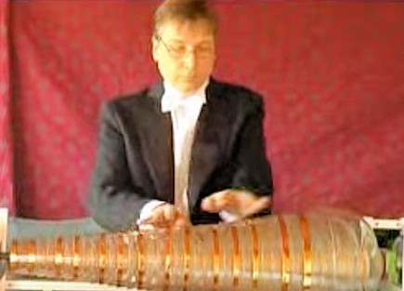
So, Franklin cut the stems off the glasses and mounted them on a shaft that could simultaneously spin all the glasses while applying wet fingers to make the sound. Some well-known composers wrote music for Franklin’s instrument, but it never took off. Maybe it did not travel very well.

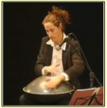
The next time you finish your soft drink, you might take the soda straw and see if you can duplicate this soda straw recorder . Here is a video that shows how to make a straw recorder.

The picture here shows a woman playing what looks like an old barbecue grill cover, but it’s actually called a Hang Drum. Although the name hints that it might be Chinese, it actually comes from Switzerland. It makes some very interesting sounds.


The Hang Drum is constructed from two half-shells of deep drawn, nitride steel sheet glued together at the rim leaving the inside hollow and creating a distinct 'UFO shape'. The top ("Ding") side has a center 'note' hammered into it and seven or eight 'tone fields' hammered around the center. The bottom is a plain surface that has a rolled hole in the center with a tuned note that can be created when the rim is struck. – Wikipedia

Here is a cute but weird thing. This guy has arranged a collection of kitten squeeze toys and uses them to play Somewhere Over the Rainbow.

Now we get back to Wintergatan. One of their productions that has gotten a bit of attention is the Rube Goldberg looking marble machine.
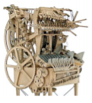
The machine is powered by hand, and works by raising 2,000 steel marbles through the machine into multiple feeder tubes, where they are then released from height via programmable release gates, falling and striking an instrument below. All the instruments are played by striking them and include a vibraphone, bass guitar, cymbal, and emulated kick drum, high hat and snare drum sounds using contact microphones. The music score is stored on two programmable wheels that utilize Lego Technic beams and stud connectors to trigger armatures to release the marbles.

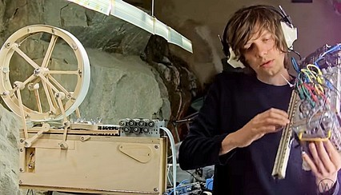
If you find the marble machine interesting you may also like this entry from Wintergatan.

